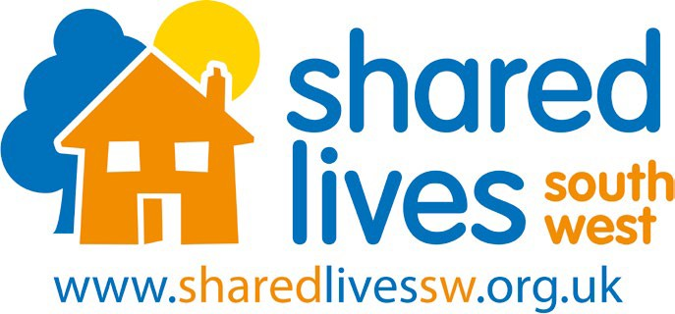
INFORMATION FOR TRUSTEES

About Shared Lives South West

Shared Lives South West recruits, trains and supports individuals and families (Shared Lives Carers) who can offer accommodation and care for adults with care and support needs in their home, enabling the person to share in family life and maintain their independence. This is known as Shared Lives.

Our service supports adults over 18 years of age and occasionally young people in transition into adult services from the age of 16 upwards. We currently support around 320 people on a long-term basis in around 290 shared lives homes and have up to a further 130 people using our short break services. We provide support to people with learning disabilities, people who have a diagnosis of dementia, a physical or sensory disability, mental ill health and parents who have a learning disability with their child. We currently have five contracts from Local Authorities across Cornwall, Devon and Somerset to support our work and a range of project funding totalling around £1.8 million per annum.

You can read more about the activities of Shared Lives South West on our website; www.sharedlivessw.org.uk

Shared Lives South West is a registered charity and a not-for-profit company limited by guarantee. We were set up in 2004.

If I join Shared Lives South West as a Trustee what can I expect?

You will be joining an enthusiastic and committed team of eight Trustees. Induction and training for the role will be provided. The appointment will run for three years and be subject to an annual review with the Chair of the Board. Two further terms of three years may be agreed. You will be required to sign a confidentiality agreement, declare any relevant business interests and complete an insolvency check as well as a charity related parties register prior to your first Board meeting. You will be required to declare, on an ongoing basis, any further relevant business interests and/or conflicts of interest that may arise.

You will help enrich the lives of people we support by becoming a part of this friendly charity known for providing high quality support to people as recognised by our recent “Outstanding” CQC award. You stand to also enrich your own life through the empowering and satisfying sector of volunteering as well as having access to training and development opportunities through Shared Lives South West.

This is a voluntary post and would be offered subject to satisfactory references and DBS check. Travel expenses can be claimed.

How do I apply?

If you would like an informal chat about the role, please contact Claire Waring, People Team Assistant on cwaring@sharedlivessw.org.uk and Claire will arrange a call for you with the Chair of the Board of Trustees. Application packs can also be requested using this email address.

We welcome people regardless of age, disability, gender identity, marital status, race, faith or belief, sexual orientation and socioeconomic background and welcome applications from people who hold these identities

Please complete the application form (CV’s alone are not accepted) and return it via post or email. All candidates will be notified if selected for interview or not. Application forms can be requested by post, email or downloaded in full from our website www. sharedlivessw.org.uk
If you have any queries about the recruitment process, please contact Claire Waring, People Team Assistant on cwaring@sharedlivessw.org.uk or our Devon office on 01626 360170.

