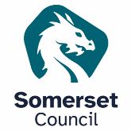 Somerset Learning Disability Partnership Board

Do you or someone you live with/support have a Learning Disability?
You are warmly invited to the Learning Disability Partnership Board.

What is it?
The Board is a meeting to decide how the Partnership of people with a Learning Disability and Somerset Council, NHS and others can work together.

Why would you want to come along?
 | Help shape local services for people with Learning Disabilities
 | Share your experiences and ideas, influence plans and decisions
 | Meet like-minded people and have your voice heard

Where and when will it be?
We will meet at Deane House, Taunton TA1 1HE on Tuesday 28th April 2026, 1-3pm.

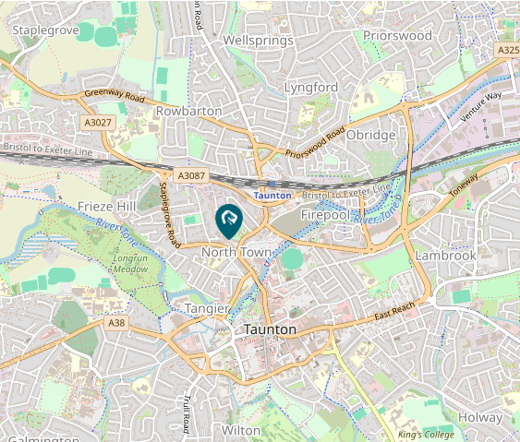

This is an accessible Council building with car parking spaces available.

What do I have to do?
Email sarah.strange@somerset.gov.uk or call 01823 357796 if you have any questions or need us to do anything to support you. Please also tell us if you plan to come to the meeting so we can prepare. You can also contact us if you cannot come to this meeting but want to find out more or get involved in a different way.

